EXPERIMENT-1
Create a simple HTML page displaying personal details using text formatting tags.
Program-
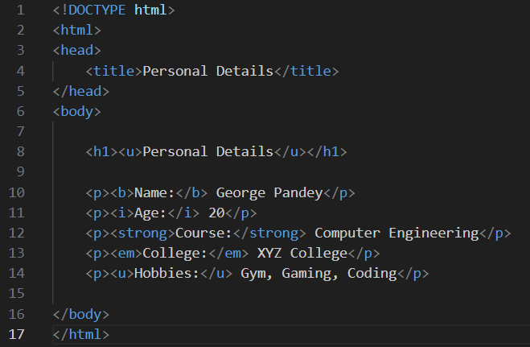

Output-
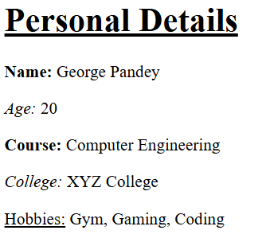

EXPERIMENT-2
Design a web page that includes an image, hyperlink, and a nested table.
Program-
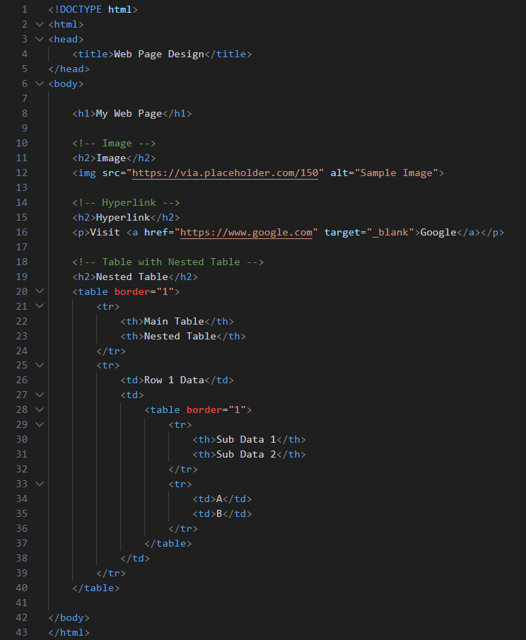

Output-
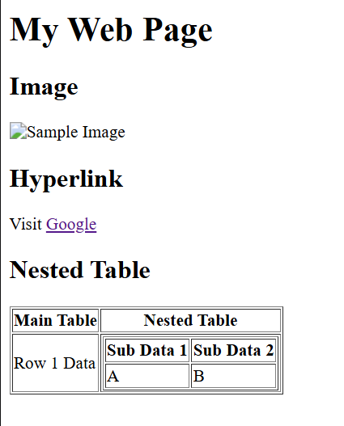
EXPERIMENT-3
Create a form with fields: name, email, gender, date of birth, and submit button.
Program-
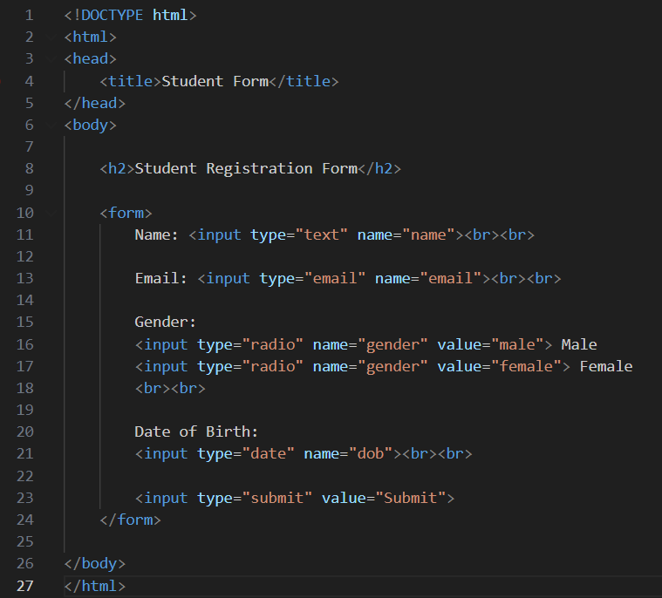

Output-
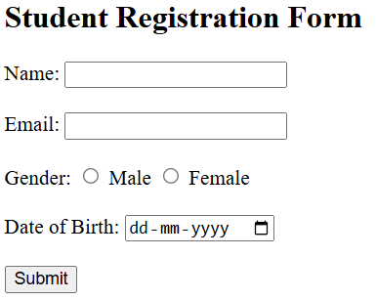

EXPERIMENT-4
Apply internal, external, and inline CSS to style a web page with headings and tables
Program-
HTML-
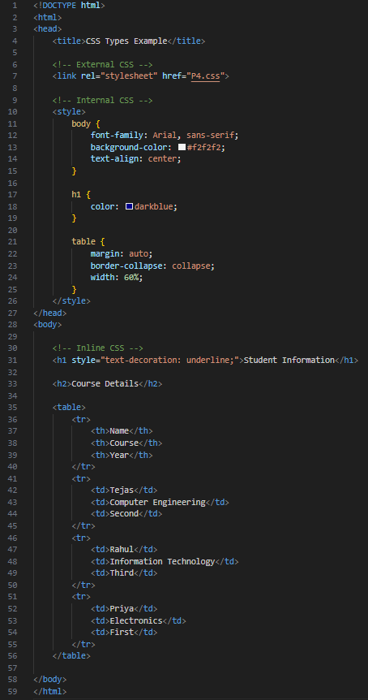

CSS-
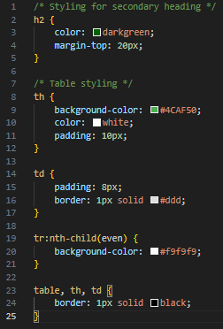

Output-
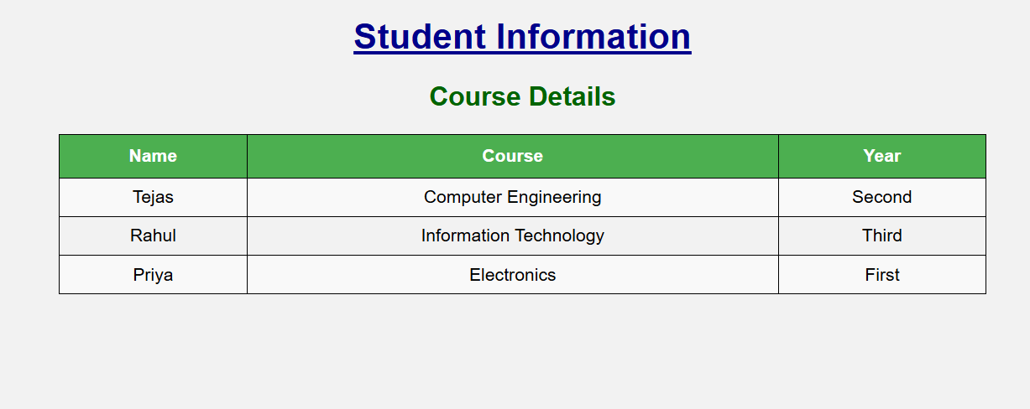

EXPERIMENT-5
Develop a responsive web page using Bootstrap Grid and Components.
Program-
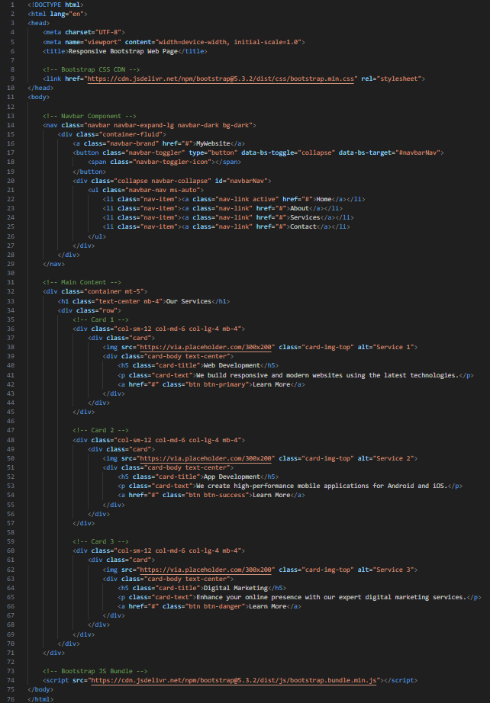

Output-
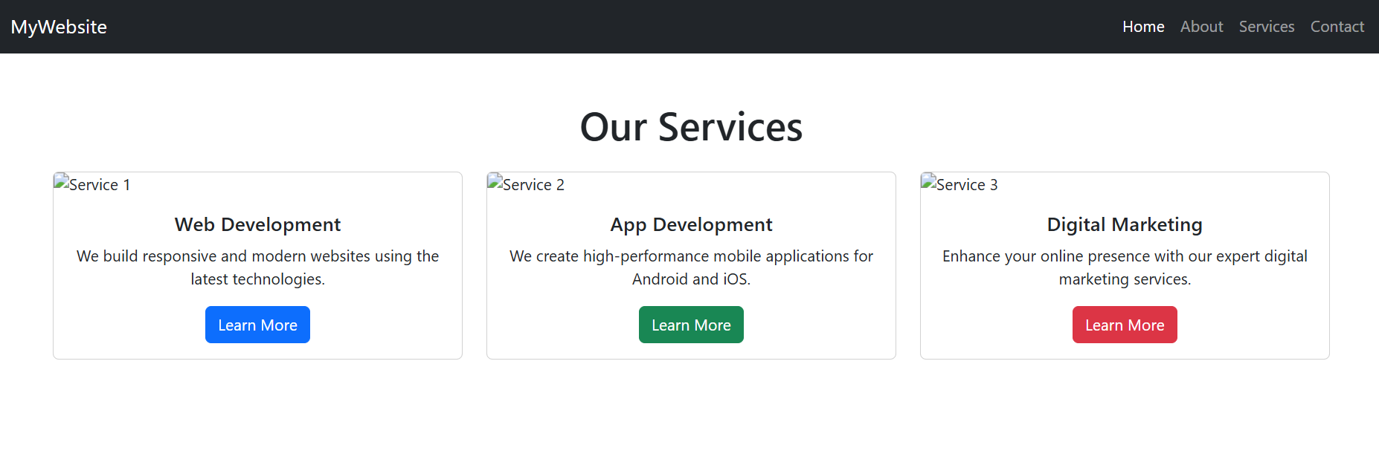

EXPERIMENT-6
Write a JavaScript program to validate form inputs (e.g., email, empty fields).
Program-
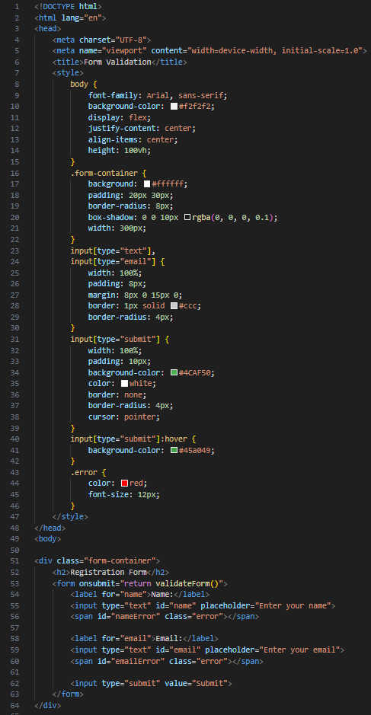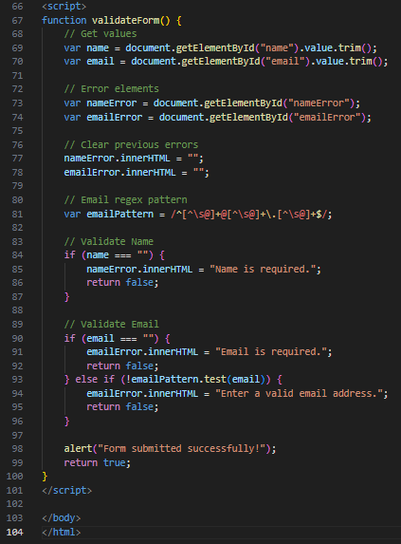

Output-
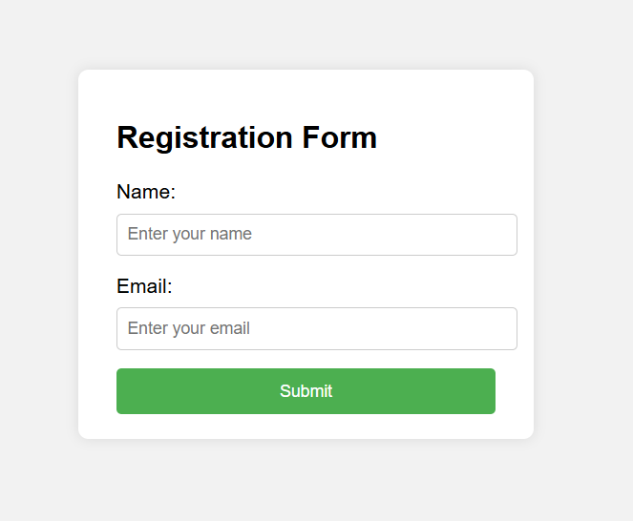
EXPERIMENT-7
Create a web page that uses JavaScript to display dynamic content using DOM.
Program-
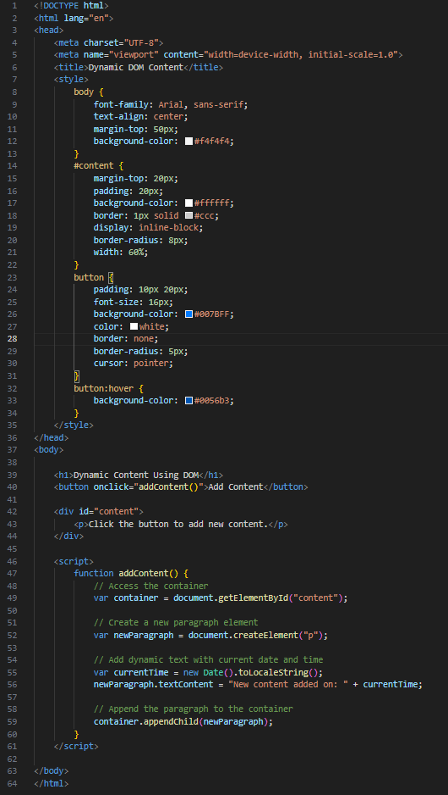
Output-
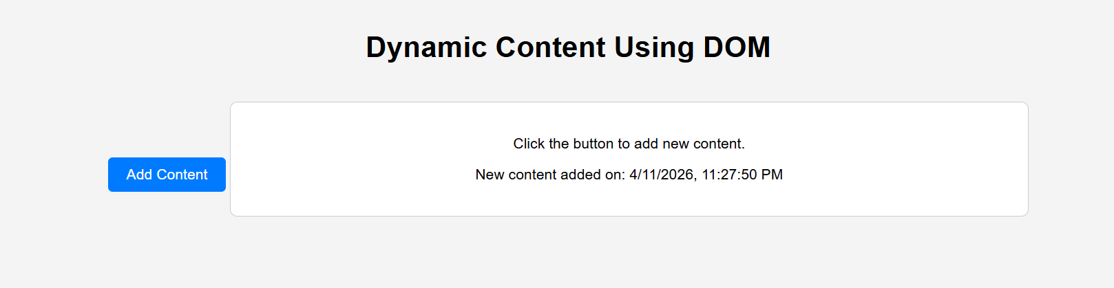
EXPERIMENT-8
Write a JavaScript program for a simple calculator using functions and switch-case.
Program-
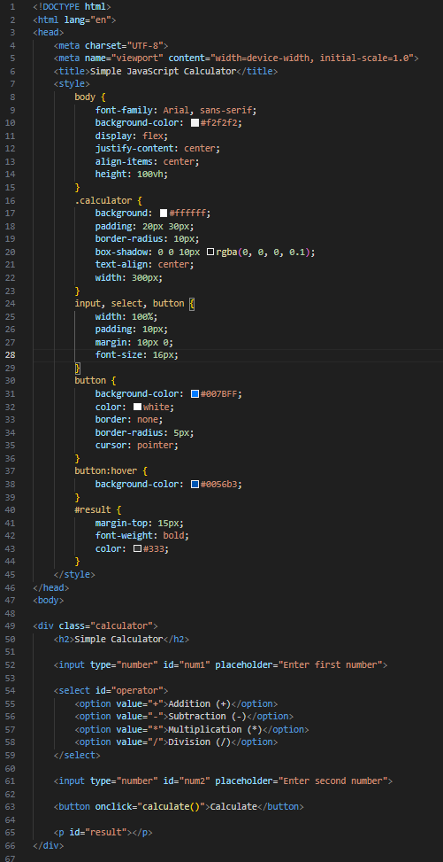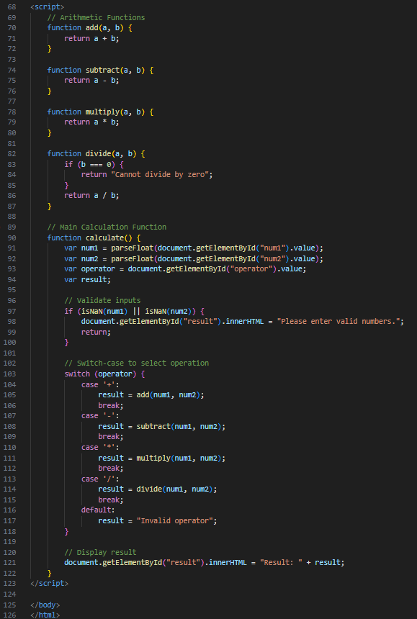

Output-
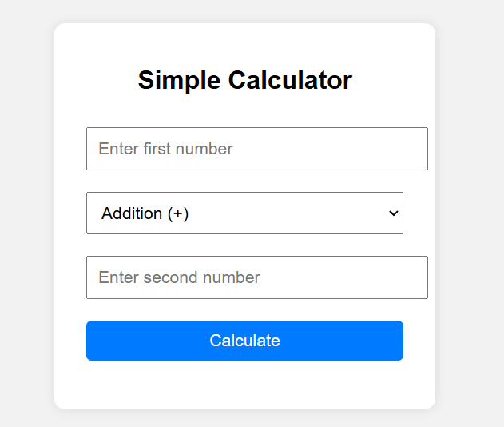

EXPERIMENT-9
Design a PHP script to display "Welcome" message and current date & time.
Program-
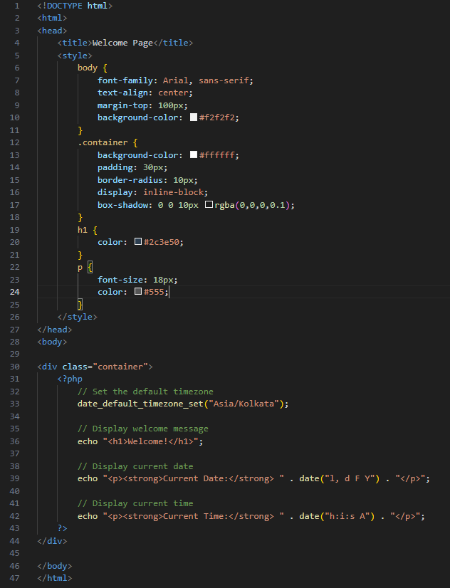

Output-
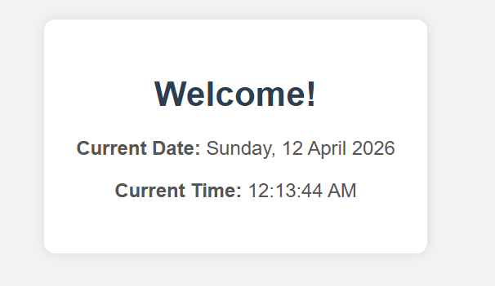
EXPERIMENT-10
Write a PHP program to accept form input and display it using the POST method.
Program-
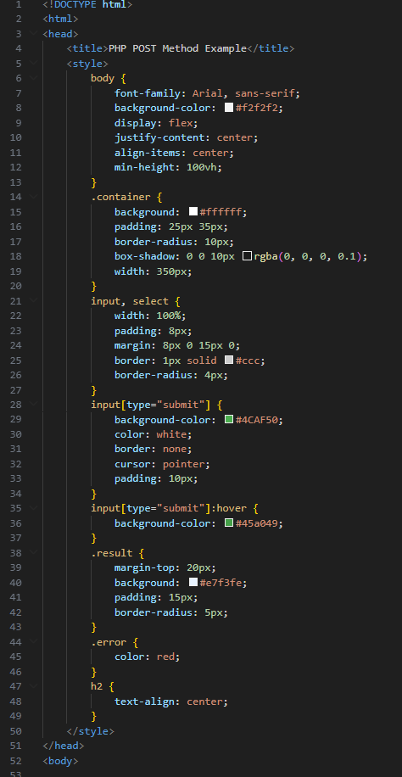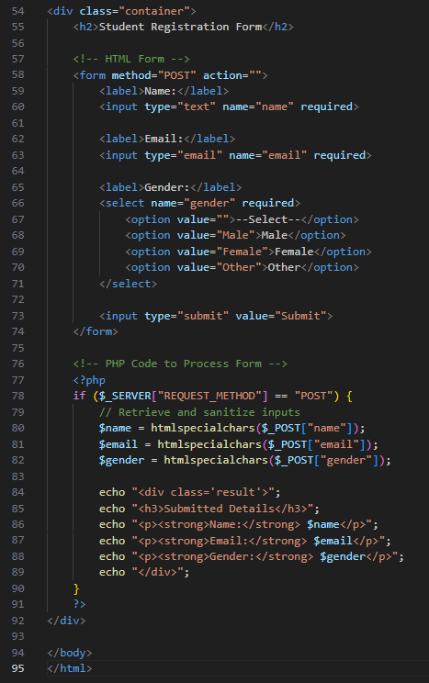
Output-
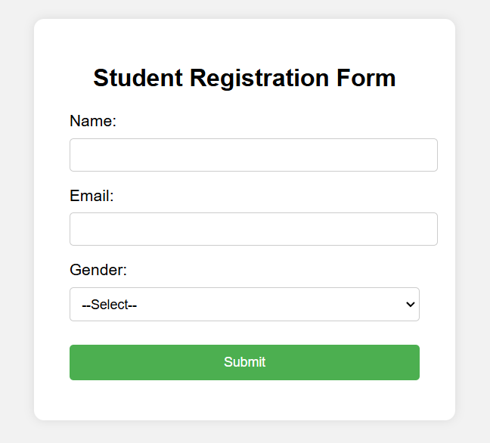
EXPERIMENT-11
Implement a PHP program for string manipulation (e.g., reverse, length, substring).
Program-
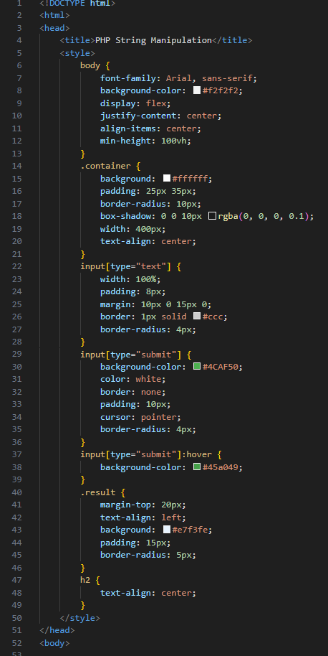

Output-
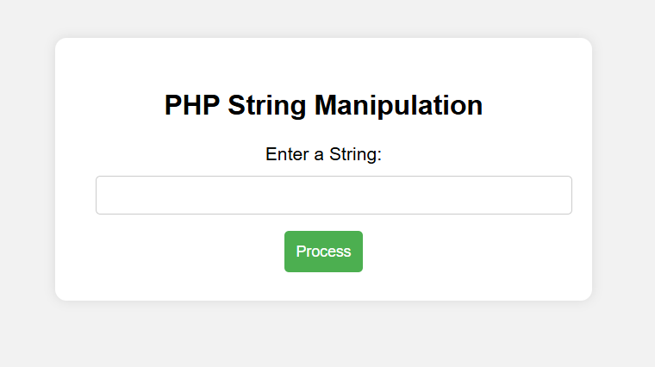
EXPERIMENT-12
Create a PHP script to store and display values in an array.
Program-
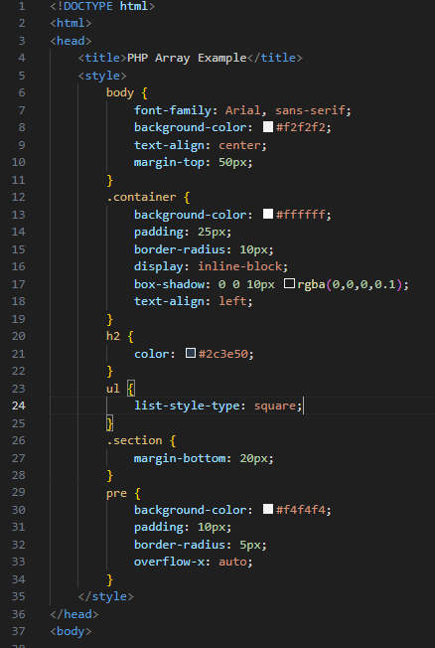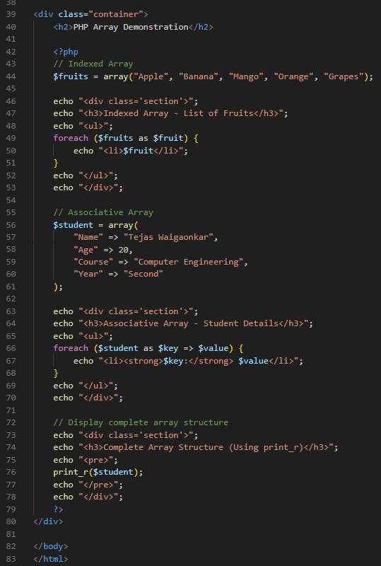

Output-
